2013 Native Grass ID Short Courses
Expression of Interest Form

Places are strictly limited in the 2013 Native Grass Identification Short Courses to be held in Kerang and St Arnaud. The course is open to farmers and Landcare members in the North Central CMA region. To submit an expression of interest (EOI), please complete your contact details and the questionnaire below.

Full sponsorship is available for 15 successful applicants at each course. Sponsorship will cover the course fees, field trip transport, morning tea and lunch on both days. Please note that the sponsorship doesn’t include accommodation or travel costs to Kerang or St Arnaud to attend the course.

To receive a sponsorship, applicants must be one or more of the following:
- A member of a community natural resource management group (e.g. Landcare, Friends of Groups, Conservation Management Groups, etc)
- Be actively involved in a farm business
- Own or manage a rural property.

Successful applicants will be notified on 16 October 2013. Expressions of interest should be submitted to the North Central CMA by 5 pm Monday 14 October 2012 by emailing info@nccma.vic.gov.au or via post to PO Box 18, Huntly VIC 3551.

Contact Details

Title: _______First Name: ______________________Surname: ____________________________

Postal Address: ____________________________________________________________________________
_________________________________________________________________________________________
_________________________________________________________________________________________
_________________________________________________________________________________________

Phone (Home): ____________________________ (Mobile): _________________________________

E-mail: ___________________________________________________________________________________

Expression of Interest Questionnaire

- Which course would you like to attend? (Please circle)

Kerang St Arnaud

- Why would you like to attend the 2013 Native Grass Identification Short Course? (In 25 words or less)

- How will you share the knowledge gained from the course with your local agricultural or Landcare community? (In 25 words or less)

- Are you a member of a community NRM group, own or manage a rural property and/or a farmer in the North Central CMA region? Please circle the area where you live on the map.

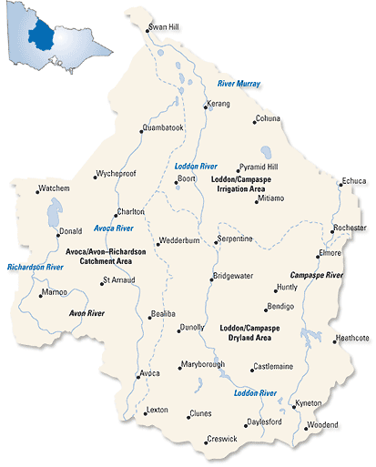
Map of North Central CMA region.

- Is there any other information you would like to provide regarding your expression of interest? (In 25 words or less)

Privacy Statement

Please read this information carefully before signing below:

The North Central CMA may use the information collected on this form for the following purposes:
- Expression of Interest information collected in connection with applicants for work; and,
- Information obtained to assist in managing client and business relationships.
We may disclose your personal information for the purpose for which it is primarily held, or for a related secondary purpose. In some cases we may only disclose information with your consent.

Personal details will not be added to any mailing list, used for marketing purposes or shared with any third party without your consent.

For information regarding our compliance with the Privacy Act please ask our staff for a copy of our Privacy Policy.

Signed: ____________________________ Date: ____________________

